Finding the sweet spot in camera trapping: a global meta-analysis of sampling intensity and incidence capture rates.

Need to work on latter bit of title but something like

Nargol Ghazian^{1*} and Christopher J. Lortie¹
¹Department of Biological Science, York University, 4700 Keele St, Toronto, ON M3J 1P3, Canada

*Corresponding Author: Department of Biology, York University, 4700 Keele St, Toronto, ON, M3J 1P3, Canada. Email: nargolg1@my.yorku.ca

Abstract
- Camera traps have become one of the most common tools in wildlife biology and their use is prevalent in many studies examining activity patterns, animal behaviour. Captures can be used to estimate population parameters such a relative abundance and also local species diversity.

- A total of 252 full-text articles were returned from the Web of Science using the search terms. … Full-text reviews of each for sampling effort in total number of days and total number of cameras generated 119 studies the reported animal abundance and species richness captured using this tool. A meta-analysis of the incidence rates, i.e. number of successful captures per total photographs, was used to examine whether sampling effort predicted vertebrate abundances or diversity in a meta-regressions.
- The net positive effect of increasing the number of cameras was positive - study over - keep results tense in the past. Increased depoylment of higher numbers of camera traps returns higher net capture rates particularly in deserts and grasslands, and higher diversity in most ecosystems. Increasing the duration of trapping did not consistently increase capture rate or diversity.
- Camera trapping will continue to increase in use in ecology and evolution, and it is thus important to examine effective experimental designs to increase the likelihood of sufficient data.

Keywords
Abundance, Camera traps, diversity, population estimates, richness, sampling effort, meta-analysis, incidence rates, meta-regressions

Introduction
Camera traps are a primary tool to survey wildlife and their interactions with the surrounding environment with relatively limited human interference. These survey devices normally record animal presence via a triggered passive, infrared motion sensor (Marcus Rowcliffe et al. 2011). They are one of the most popular survey tools in current wildlife research particularly in the domain of terrestrial vertebrate biology (P. Meek et al. 2014). Cameras can record activity patterns and be used to infer occupancy, abundance, and species diversity (Karanth et al. 2004; Kelly et al. 2008). Besides their use in wildlife research, camera traps have been used in studies that focus on nest ecology (citation), detection of rare species (Citation), estimation of population size and species richness (citation), behaviour (etc), habitat use, and occupation of human-built structures (Cutler and Swann 1999; O’Connell et al. 2011 ). If you are going to try for MEE - need to state where how they advance theory to big picture web too - ie Data from camera traps also advances… x theory *(cite MEE paper such as Quantifying levels of animal activity using camera trap data
J. Marcus Rowcliffe Roland Kays Bart Kranstauber Chris Carbone Patrick A. Jansen
Methods in Ecology and EvolutionVolume 5, Issue 11
First published: 12 September 2014 OR any that talks about how to use cam trap data (not process photos etc) for ecology and evolution - - there are 124 paper in MEE with camera trap in them - use a few here and ensure sprinkle. A few citations to them throughout ms as wellThus, camera traps are a versatile method for collecting data on the functioning of many systems that can be used for a variety of management and conservation practices. See implications in paper pasted below - Do not copy their salespitch of course but I think instead of using popularity as the criterion use something else - ie we need to be able to measure biodiversity in different ways particularly for species that are not plant etc. and move around and cam traps provide one relatively easy method to enable this…

Have you seen this paper?
An empirical evaluation of camera trap study design: How many, how long and when?
- Roland Kays Brian S. Arbogast Megan Baker‐Whatton Chris Beirne Hailey M. Boone Mark Bowler Santiago F. Burneo Michael V. Cove Ping Ding Santiago Espinosa André Luis Sousa Gonçalves Christopher P. Hansen Patrick A. Jansen Joseph M. Kolowski Travis W. Knowles Marcela Guimarães Moreira Lima Joshua Millspaugh William J. McShea Krishna Pacifici Arielle W. Parsons Brent S. Pease Francesco Rovero Fernanda Santos Stephanie G. Schuttler Douglas Sheil Xingfeng Si Matt Snider Wilson R. Spironello
Methods in Ecology and EvolutionVolume 11, Issue 6
Various crucial aspects can influence the number of species detected by camera traps, as well as the trapping rate (ratio of photographs to camera trapping time (Rovero and Marshall 2009) - I think citations you are using in paper are a bit dated - can you update them a bit?. These include trigger speed, detection zone, recovery time, night detection, and battery consumption that can impact the collected data (Hughson and Darby 2010). Limitations of this method can also arise from camera models, placement and orientation, temperature differentials, and species behavioural responses (P. D. Meek, Ballard, and Fleming 2015). The factors can be summarized as trapping effort and trapping design and can affect estimates of abundance and diversity (Yasuda 2004; Wegge, Pokheral, and Jnawali 2004). Meh - maybe on this paragraph… if you keep it. Make clear how and why these design decisions matter to ecology and evolution Or cut or link to experimental design.. or just skip to the MEE paper, explain what they did, and then how this synthesis innovates and extends on that paper?
Trapping or detection? rate is a useful index for abundance and diversity estimates (Rovero and Marshall 2009; J. Marcus Rowcliffe et al. 2008; Silveira, Jácomo, and Diniz-Filho 2003). Minimum trapping effort (MTE) is another important factor for population estimates (citation). MTE refers to the number of camera trap days required to record species of interest in an area (Si, Kays, and Ding 2014) and varies extensively across studies. The number of camera traps used in a study is directly related to both trapping design and effort because a small number of cameras can result in low detection probabilities and affect the strength of population estimates (Foster and Harmsen 2012). The interplay amongst these elements provides us with an excellent opportunity to explore the relationship between trapping time, number of cameras, and richness estimates across the literature. again… not popping - make it pop here
Here, we used a meta-analysis of the global peer-reviewed literature to test the hypothesis that sampling effort positively but non-linearly influences . We tested the threshold for sampling and provided an overview of the relationship between sampling effort in days influenced the incidence rates for abundance, and total vertebrate species richness. Why do you keep dropping abundance? I think it is the semantics - be clear we use incidence rate for That is fig 2 (see results for proposed re-ordering). The importance of ecosystems was also examined. Given that camera traps are increasingly being used in ecology and evolution in general (Citation?), our study provides a insight into the ‘sweet spot’ in potentially sampling in different systems. The capacity fo this method to provide meaningful and sufficient animal data will better inform conservation and management practices and fundamental theory.

Methods
Literature review
We conducted a systematic review using the terms Camera Trap* AND Richness*, Camera* Trap* AND Diversity*, and Camera Trap* AND Rarefaction* Curve* in ISI Web of Science (WoS) (citation to it here). This search was done in April 2021 (ie update it and check to see if any new papers, then we can add them - I bet loads but almost none with new data - a two-year old search will not cut it). Additionally, we conducted supplemental searches in book chapters and Google Scholar to validate the publication coverage of WoS. This process resulted in a total of 397 publications once duplicates were removed. A PRISMA diagram illustrates the exclusion and review process (2009)(Supplementary material, Figure 1). We screened the abstracts and excluded papers based on relevance, whether they were a review, opinion, or idea paper, and if they focused on one species and were not quantitative - revise - check some metas - need to more formal - Exclusion criteria included reviews, commentaries, . See how I explained in this meta etc https://besjournals.onlinelibrary.wiley.com/doi/10.1111/1365-2745.13664 A total of 252 full-text articles were further reviewed for a measure of richness or diversity, the number of captures, and duration of camera trapping (i.e. days). - did they have to include all three elements?Variables such as the number of cameras, sites, and ecosystem were also recorded.

Meta-analyses
All meta-statistical analyses were performed in R version 4.0.4 (R Development Core Team 2021) using the package metafor (citation)_. Species richness and the number of captures were independent event count variables and treated as raw incidence rates using the number of cameras in effect size calculations (PT Higgins, Li, and Deeks 2021). The function escalc was used to calculate incidence rate etc… and then like to your explanation of why that measure — etc just use more direct language Effects sizes were calculated using the function escalc from the metafor package (Viechtbauer 2010). Random-effects models (rma) were applied to analyze estimate values and stand error for the number of cameras (sampling effort) and the number of captures and species diversity method = "ML", test = “knha", explain maximum likelihood etc.. Heterogeneity in models was examined to ensure that variance was not unduly inflated from grouping similar measures into the random-effect models (Langan et al. 2019). Close - just a bit more detail I think then done here.

Results
A total of 119 articles were included in this meta-analysis. Most studies were either conducted in tropical or deciduous forests (figure? Or just state relative frequencies in parentheses). The mean net effects of camera trapping was significantly positive (132.9475 ± 35.6037, p<0.0001, Figure 1 - the new one - Forest plot). There was significant heterogeneity between groups (Q = 299612.31, p<0.0001) with some system have relatively low capture rates and associated variances whilst higher rates were associated with greater variance (fig 1). The net effect of camera traps on rate of capture for vert… species richness etc (Fig 2 Forest plot). Ecosystem was a signficant moderator in both abundance and richness capture rates (F = 5.6266, p-Value = 0.0002). Then get to the regressions new fig 3 and 4 The relationship remained positive in all systems but was only significant in deserts and grasslands (Table 1 and SA, D). Significant heterogeneity between groups was observed (Q = 237835.99, p = 0.0002). Additionally, the number of camera trap days was not a significant moderator in this model.
Subsequently, we modeled the effect between the number of cameras and richness found a smaller effect size than the above model, though still significantly positive (0.7878 ± 0.1064, p<0.0001, Figure 1). Heterogeneity between groups was significant (Q = 94675.90, p<0.0001). Ecosystem was a significant moderator in this model (F = 16.15, p<0.0001) and animal richness significantly increased with the number of cameras in all ecosystems except coniferous forest (Table 2 and SA, E). The number of days was also not significant as a moderator in this model. Both the capture rate and richness rate were different from the null effect in all systems (SA, Figures 3 and 4, forest plots). Revise etc like above and other metas see two JECOL papers.. be direct…. Like There was a significant positive effect of increasing sampling days on the incidence or capture rate (i.e. per camera deployed) in total abundance of animals detected (Fig 3, cite table with stats) and on richness (Fig 4, cite table with stats). Ecosystem was an important moderator in meta-regressions etc..

I think the results are pretty direct

When you update research with new papers from 2020 till now etc. we can quickly re-run stats… so this will all change a tiny bit.

Discussion
Topic sentence first.. The importance of effective wildlife detection and effectively estimating biodiversity is fundamental to... etc.. There hypothesis that increasing sampling efforts in terms of number of days per cam trap deployed etc… was supported… Even more simply, the mean effect sizes of incidence or detection rates was significantly positive in all ecosystems tested here suggesting that cam traps are an effective tool to estimate relative abundances of animals and local specie richness… etc.. then end this paragraph with implications..

Reorganize below..

OK so para 1: Big picture - hypothesis supported
Para 2 - camera traps work, GLOBALLY IN ALL ECOSYSTEMS… Here, we primarily examined the relative importance of days but the net positive effect size estimates of incidence rates, ie captures per number of cameras, suggest that…
Para 3 - Topic sentence - sampling effort is critical design topic in all of ecology and evolution particularly in field studies. etc..
Para 4 - implications and link to that other MEE paper and summarize recommendations… or have as implications instead - your call..

Our results demonstrate the utility of camera traps as a tool in population estimate studies. In the last 20 years, camera traps have not only become more readily available as a tool but have also become more affordable (J. M. Rowcliffe and Carbone 2008), which is good news for conservation, ecology, wildlife, and species inventory studies. Their popularity in richness estimate studies (Tobler et al. 2008b; 2008a) provides us with the opportunity to explore aspects related to experimental design, intending to develop future frameworks that aid in the optimization of camera trapping procedures. The idea that trapping may be influenced by the number of cameras was supported here with increased number of cameras returning significantly higher capture rates specifically in grasslands and deserts. We demonstrated that increased number of cameras also resulted in higher diversity in almost all ecosystems, except for coniferous forest. Additionally, it did not come as a surprise that increasing the number of trapping days past a certain point did not increase the capacity of the number of cameras to detect more animal species. This evidence suggest that the chosen system of study may be key to enhancing trapping effort and offers a great deal of promise for the utilities of camera traps in arid scrubland and grassland.

The number of cameras used in the study affects the trapping effort. We found that the net effect of increasing the number of cameras was positive. As well, the increase in the number of cameras resulted in the highest captures of animal diversity. According to Ferreras et al. (2017) success in detecting all the species in the system depends on many factors, including the number of cameras. They too suggest that it is more efficient to deploy more camera traps for a shorter duration rather than to deploy fewer camera traps for a longer one, for any given number of camera traps days. There is an enormous expansion in the number of sites that camera traps are being used and most literature acknowledges the fact that one cannot discuss the notion of the number of cameras without talking about how far apart cameras were placed and how extensively the site was studied. Trap placement designs are important and the use of systematic trap placement design or a design suited to the habitat may be appropriate if the primary goal of the survey is richness estimation (O’Brien 2008). To limit the chance of missing species, camera traps should not be too close together and maximize the total area covered (O’Connell, Nichols, and Karanth 2011). The interrelatedness of camera trap placement and the number of cameras is not an idea that we explored per se, though is integral in maximizing the potential of camera traps for wildlife monitoring.

The duration of camera trapping has to be adequate-enough so that rare species can be detected (O’Brien, Kinnaird, and Wibisono 2011). Previously, we discussed the idea of MTE and its variation across the literature. Differences in the number of camera trap days across studies are related to animal richness at the site. MTE can be affected by habitat, local characteristics, target community, and sampling strategy, including camera spacing, presence or absence of bait, and camera models (Kelly 2008; Rovero and Marshall 2009; Wegge, Pokheral, and Jnawali 2004). Our analysis showed that increasing the number of days does not augment the capacity of cameras to sense more animals, in the number of captures or diversity, in any of the systems. This is consistent with the analysis of (Si, Kays, and Ding 2014) who demonstrated that increasing the number of camera sites and rotating cameras to new sites is more efficient for richness estimates as opposed to leaving cameras at the same site for a longer duration of time. This is because regardless of the system of study, after a certain number of days species rarefraction level-off and a longer trapping period does not result in increased diversity. Hence, to increase the likelihood of detection, we suggest taking the above factors into consideration when designing the study, as well as increasing the number of sites and cameras, and rotating cameras.
It was striking that although grasslands and deserts were not the most popular system of study, increasing the number of cameras significantly increased the rate of animal captures in these systems. Arid ecosystems are globally threatened with increased rates of anthropogenic changes, such as climate change and land-use (Mahmoud and Gan 2018), and species in these regions are faced extensive ecological shifts (Barrows 2011; Bachelet et al. 2016). Thus, the intensive monitoring of local species in these regions will be critical for the maintenance of biodiversity and implementation of management practices in the years to come. Our results offer new and exciting insight into the utility of camera traps as a tool in dryland wildlife monitoring and show promising outcomes for conservation and restoration strategies. Camera traps are a powerful instrument that allow for the monitoring of terrestrial communities with little human bias. In the years to come, not only will their popularity increase as an stand-alone tool but we will also see a rise in their cross implementation in AI environmental monitoring studies. Future challenges for researchers will include well-planned experimental designs to maximize the extent of surveys.

Acknowledgments
This research was made possible through a Natural Sciences and Engineering Research Council of Canada (NSERC) grant awarded to CJL. NG and CJL declare no conflict of interest.
Author’s contributions
CJL and NG designed the study and methodologies; NG wrote the manuscript; CJL analyzed the data; CJL thoroughly edited the manuscript and contributed critically.

Work Cited
Bachelet, D., K. Ferschweiler, T. Sheehan, and J. Strittholt. 2016. “Climate Change Effects on Southern California Deserts.” Journal of Arid Environments 127 (April): 17–29. https://doi.org/10.1016/j.jaridenv.2015.10.003.
Barrows, C.W. 2011. “Sensitivity to Climate Change for Two Reptiles at the Mojave–Sonoran Desert Interface.” Journal of Arid Environments 75 (7): 629–35. https://doi.org/10.1016/j.jaridenv.2011.01.018.
Cutler, T.L., and D.E. Swann. 1999. Using Remote Photography in Wildlife Ecology: A Review. Vol. 27.
Ferreras, P., F. Díaz-Ruiz, P. C. Alves, and P. Monterroso. 2017. “Optimizing Camera-Trapping Protocols for Characterizing Mesocarnivore Communities in South-Western Europe.” Journal of Zoology 301 (1): 23–31. https://doi.org/10.1111/jzo.12386.
Foster, Rebecca J., and Bart J. Harmsen. 2012. “A Critique of Density Estimation from Camera-Trap Data: Density Estimation From Camera-Trap Data.” The Journal of Wildlife Management 76 (2): 224–36. https://doi.org/10.1002/jwmg.275.
Hughson, D.L, and N.W Darby. 2010. “Comparison of Motion-Activated Cameras for Wildlife Investigations” 96 (2): 101–9.
Karanth, K. U., J. D. Nichols, N. S. Kumar, W. A. Link, and J. E. Hines. 2004. “Tigers and Their Prey: Predicting Carnivore Densities from Prey Abundance.” Proceedings of the National Academy of Sciences 101 (14): 4854–58. https://doi.org/10.1073/pnas.0306210101.
Kelly, M. J. 2008. “Design, Evaluate, Refine: Camera Trap Studies for Elusive Species.” Animal Conservation 11 (3): 182–84. https://doi.org/10.1111/j.1469-1795.2008.00179.x.
Kelly, Marcella J., Andrew J. Noss, Mario S. Di Bitetti, Leonardo Maffei, Rosario L. Arispe, Agustin Paviolo, Carlos D. De Angelo, and Yamil E. Di Blanco. 2008. “Estimating Puma Densities from Camera Trapping across Three Study Sites: Bolivia, Argentina, and Belize.” Journal of Mammalogy 89 (2): 408–18. https://doi.org/10.1644/06-MAMM-A-424R.1.
Langan, Dean, Julian P.T. Higgins, Dan Jackson, Jack Bowden, Areti Angeliki Veroniki, Evangelos Kontopantelis, Wolfgang Viechtbauer, and Mark Simmonds. 2019. “A Comparison of Heterogeneity Variance Estimators in Simulated Random‐effects Meta‐analyses.” Research Synthesis Methods 10 (1): 83–98. https://doi.org/10.1002/jrsm.1316.
Mahmoud, Shereif H., and Thian Y. Gan. 2018. “Impact of Anthropogenic Climate Change and Human Activities on Environment and Ecosystem Services in Arid Regions.” Science of The Total Environment 633 (August): 1329–44. https://doi.org/10.1016/j.scitotenv.2018.03.290.
Marcus Rowcliffe, J., Chris Carbone, Patrick A. Jansen, Roland Kays, and Bart Kranstauber. 2011. “Quantifying the Sensitivity of Camera Traps: An Adapted Distance Sampling Approach: Quantifying Camera Trap Sensitivity.” Methods in Ecology and Evolution 2 (5): 464–76. https://doi.org/10.1111/j.2041-210X.2011.00094.x.
Meek, Paul D., Guy-Anthony Ballard, and Peter J. S. Fleming. 2015. “The Pitfalls of Wildlife Camera Trapping as a Survey Tool in Australia.” Australian Mammalogy 37 (1): 13. https://doi.org/10.1071/AM14023.
Meek, Paul, Peter J. S Fleming, Guy Ballard, Peter Banks, Andrew W Claridge, James Sanderson, Don E Swann, Australasian Wildlife Management Society, and Royal Zoological Society of New South Wales, eds. 2014. Camera Trapping: Wildlife Management and Research.
Moher, David, Alessandro Liberati, Jennifer Tetzlaff, Douglas G. Altman, and The PRISMA Group. 2009. “Preferred Reporting Items for Systematic Reviews and Meta-Analyses: The PRISMA Statement.” PLoS Medicine 6 (7): e1000097. https://doi.org/10.1371/journal.pmed.1000097.
O’Brien, T. G. 2008. “On the Use of Automated Cameras to Estimate Species Richness for Large- and Medium-Sized Rainforest Mammals.” Animal Conservation 11 (3): 179–81. https://doi.org/10.1111/j.1469-1795.2008.00178.x.
O’Brien, T.G., M.F. Kinnaird, and T.H. Wibisono. 2011. “Estimation of Species Richness of Large Vertebrates Using Camera Traps: An Example from an Indonesian Rainforest.” In Camera Traps in Animal Ecology: Methods and Analyses / Allan F. O’Connell, James D. Nichols, K. Ullas Karanth, Tokyo: Springer, 233–52.
O’Connell, Allan F., James D. Nichols, and K. Ullas Karanth, eds. 2011. Camera Traps in Animal Ecology: Methods and Analyses / Allan F. O’Connell, James D. Nichols, K. Ullas Karanth, Editors. Tokyo ; New York: Springer.
PT Higgins, Julian, Tianjing Li, and Jonathan J. Deeks. 2021. “Choosing Effect Measures and Computing Estimates of Effect.” Cochrane Training (blog). 2021. https://training.cochrane.org/handbook/current/chapter-06#section-6-1.
R Development Core Team. 2021. R (version 4.0.4).
Rovero, Francesco, and Andrew R. Marshall. 2009. “Camera Trapping Photographic Rate as an Index of Density in Forest Ungulates.” Journal of Applied Ecology 46 (5): 1011–17. https://doi.org/10.1111/j.1365-2664.2009.01705.x.
Rowcliffe, J. M., and C. Carbone. 2008. “Surveys Using Camera Traps: Are We Looking to a Brighter Future?” Animal Conservation 11 (3): 185–86. https://doi.org/10.1111/j.1469-1795.2008.00180.x.
Rowcliffe, J. Marcus, Juliet Field, Samuel T. Turvey, and Chris Carbone. 2008. “Estimating Animal Density Using Camera Traps without the Need for Individual Recognition.” Journal of Applied Ecology 45 (4): 1228–36. https://doi.org/10.1111/j.1365-2664.2008.01473.x.
Si, Xingfeng, Roland Kays, and Ping Ding. 2014. “How Long Is Enough to Detect Terrestrial Animals? Estimating the Minimum Trapping Effort on Camera Traps.” PeerJ 2 (May): e374. https://doi.org/10.7717/peerj.374.
Silveira, Leandro, Anah T.A. Jácomo, and José Alexandre F. Diniz-Filho. 2003. “Camera Trap, Line Transect Census and Track Surveys: A Comparative Evaluation.” Biological Conservation 114 (3): 351–55. https://doi.org/10.1016/S0006-3207(03)00063-6.
Tobler, M. W., S. E. Carrillo-Percastegui, R. Leite Pitman, R. Mares, and G. Powell. 2008a. “An Evaluation of Camera Traps for Inventorying Large- and Medium-Sized Terrestrial Rainforest Mammals.” Animal Conservation 11 (3): 169–78. https://doi.org/10.1111/j.1469-1795.2008.00169.x.
—. 2008b. “Further Notes on the Analysis of Mammal Inventory Data Collected with Camera Traps.” Animal Conservation 11 (3): 187–89. https://doi.org/10.1111/j.1469-1795.2008.00181.x.
Verhagen, Arianne P, and Manuela L Ferreira. 2014. “Forest Plots.” Journal of Physiotherapy 60 (3): 170–73. https://doi.org/10.1016/j.jphys.2014.06.021.
Viechtbauer, Wolfgang. 2010. “Conducting Meta-Analyses in R with the Metafor Package.” Journal of Statistical Software 36 (3). https://doi.org/10.18637/jss.v036.i03.
Wegge, Per, Chiranjibi Pd. Pokheral, and Shant Raj Jnawali. 2004. “Effects of Trapping Effort and Trap Shyness on Estimates of Tiger Abundance from Camera Trap Studies.” Animal Conservation 7 (3): 251–56. https://doi.org/10.1017/S1367943004001441.
Wickham, Hadley. 2009. Ggplot2: Elegant Graphics for Data Analysis. Use R! New York: Springer.
Yasuda, Masatoshi. 2004. “Monitoring Diversity and Abundance of Mammals with Camera Traps: A Case Study on Mount Tsukuba, Central Japan.” Mammal Study 29 (1): 37–46. https://doi.org/10.3106/mammalstudy.29.37.

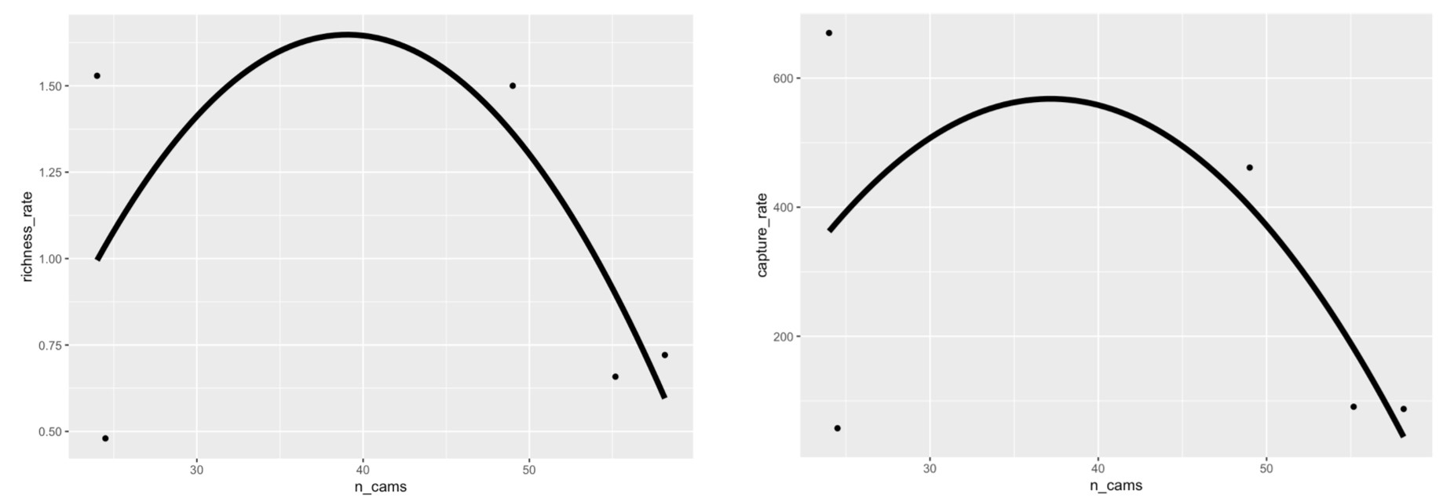
Figures and Tables see JECOL paper
Move meta-regression plots from appendix to main figure. The forest plot and meta-regression one

Figure 1. Regressions? Of the effect of number of camera traps to rate of richness and abundance captures. Then explain how it is a rate etc… I would just cut this figure really Smoothed conditional means are fitted to a linear model.

MOVE this to appendix. Or just CUT - you know what CUT

Remove _ from fig legends etc..why so few points on plots?

Table 1. Mixed Effect Model estimates?? From meta? and standard error (SE) are given for each ecosystem based on model for camera trap as sampling effort and the number of captures. Significant p-Values are bolded.

Ecosystem | Estimate | SE (±) | t-Value | ci.lb | ci.ub | p-Value
Coniferous | 57.50 | 158.63 | 0.36 | -261.61 | 376.62 | 0.719
Deciduous | 88.70 | 53.51 | 1.63 | -20.96 | 198.35 | 0.110
Desert | 431.36 | 165.4 | 2.61 | 99.34 | 763.37 | 0.012
Grassland | 525.22 | 120.85 | 4.35 | 282.10 | 786.34 | <0.0001
Mixed Forest | 297.10 | 226.91 | 1.31 | -159.39 | 753.58 | 0.197
Tropical | 81.69 | 43.39 | 1.88 | -5.56 | 168.98 | 0.066

Table 2. Mixed Effect Model estimates of what? and standard error (SE) are given for each ecosystem based on model for camera trap as sampling effort and species diversity. Significant p-Values are bolded. Combine with provious table

Ecosystem | Estimate | SE (±) | t-Value | ci.lb | ci.ub | p-Value
Coniferous | 0.48 | 0.45 | 1.07 | -0.42 | 1.38 | 0.2913
Deciduous | 0.65 | 0.16 | 4.18 | 0.34 | 0.96 | 0.0001
Desert | 1.41 | 0.47 | 3.00 | 0.46 | 2.35 | 0.0043
Grassland | 1.36 | 0.34 | 4.02 | 0.68 | 2.03 | 0.0002
Mixed Forest | 3.80 | 0.77 | 4.93 | 2.25 | 5.34 | <0.0001
Tropical | 0.66 | 0.12 | 5.37 | 0.41 | 0.91 | <0.0001

Put table 1 and 2 together - move to appendix. They are redundant with Forest plot but you can keep in Appendix.

Supplementary Appendix
Identification
Papers obtained through database searching (Web of Science) Keywords:
Camera* Trap* AND Richness*, Diversity*, and Rarefaction* Curve*
(n= 515)

(n = 1090)
Papers obtained from other sources, such as book chapter bibliographies
(n= 0)

Eligibility

Records after duplicates removed
(n = 397)
Records excluded for: relevance, review, opinion or idea paper, focus on one spices, qualitative, not English.

Records screened by abstract (n = 397)

Screening
Full-text articles assessed for eligibility (n = 252)

(n = )
Full-text articles excluded:
Not reporting richness or diversity, number of records, and any measure of duration.

Include in synthesis
(n = 119)

Included

Extracted data:
Location (latitude, longitude), camera trap days, number of records, animal richness, common name, scientific name, year, number of cameras, presence of bait, number of cameras, number of sites, and ecosystem.

A. PRISMA diagram used for camera trapping effort systematic review (Moher et al. 2009). Search done with keywords: Camera* Trap* AND Richness*, Diversity*, and Rarefaction* Curve* in 2019.

B. Forest plots showing effect sizes for richness rate (left) and capture rate (right) in different ecosystems of study. 5 categories of ecosystems were simplified from system. Means with 95% confidence intervals are plotted. Values that have longer hortizonal lines indicate more spread in the studies. Values that are closer to the vertical dashed line are less different from the null effect. Revise figure legend see JECOL meta how to write a more solid one or the MEE paper I sent.

MOVE to main results as Figure 1.
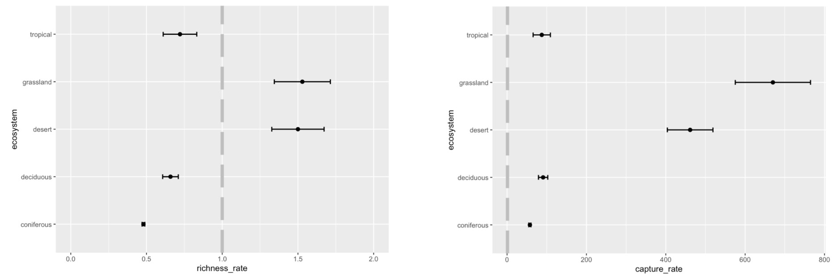

C. Scatterplot showing the relationship between the number of camera trap study days and incidence rate for animal captures. Smoothed conditional mean is fitted using the linear model. Coloured dots represent different ecosystems.
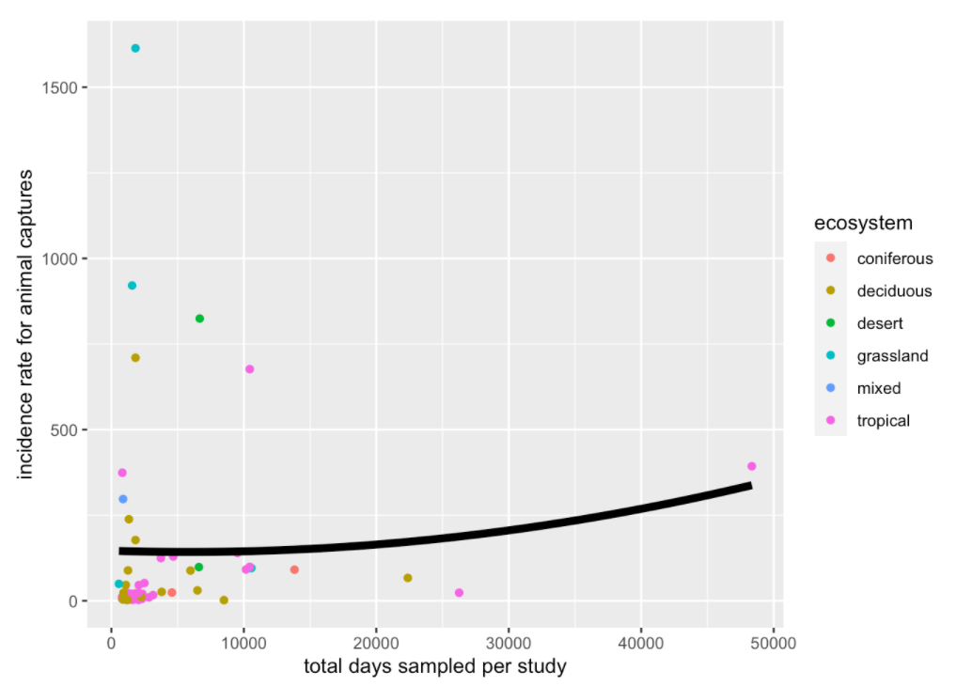

Move to main results Fig 2…

D. Scatterplot showing the relationship between the number of camera trap study days and incidence rate diversity of animals detected. Smoothed conditional mean is fitted using the linear model. Coloured dots represent different ecosystems.

Fig 3..
